CONSUMER PROTECTION ACT, 2019

Received President’s Assent on 9th August 2019 repealing the old Act of 1986.

The new 2019 act is in force from 20th July 2020.

Difference Between New Act & Old Act.

Chapters In New Act:

PRELIMINARY

CONSUMER PROTECTION COUNCILS.
CENTRAL CONSUMER PROTECTION AUTHORITY (CCPA)

CONSUMER DISPUTES REDRESSAL COMMISSION (CDRC)

MEDIATION

PRODUCT LIABILLITY

OFFENCES AND PENALTIES

MISCELLANEOUS

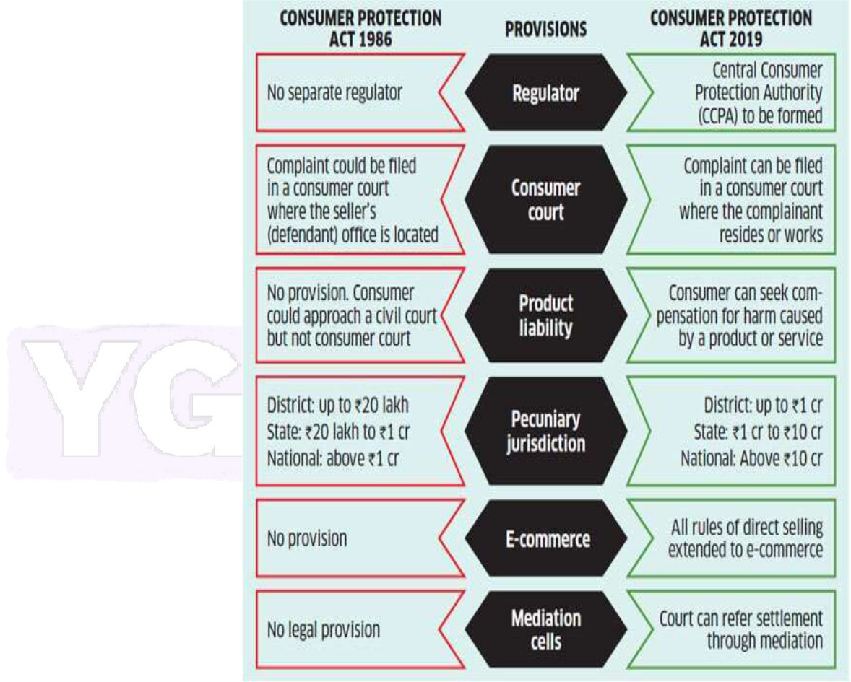

Introduction
The Consumer Protection Act, 2019 is an important legislation enacted to safeguard the interests of consumers in India. It received the President’s assent on 9th August 2019 and came into force on 20th July 2020, replacing the Consumer Protection Act, 1986.
The new Act has been introduced to address modern market challenges, including e-commerce transactions, misleading advertisements, product liability, and unfair contracts. It aims to ensure quick, simple, and effective redressal of consumer disputes and to promote consumer rights.
- Objectives of the Act
- To protect the rights and interests of consumers.
- To establish authorities for the timely and effective administration of consumer laws.
- To provide for speedy redressal of consumer grievances.
- To curb unfair trade practices and misleading advertisements.
- To ensure product safety and liability.
- Salient Features of the Act
- Establishment of the Central Consumer Protection Authority (CCPA) for regulating matters relating to violation of consumer rights, unfair trade practices, and false or misleading advertisements.
- E-filing of complaints and hearing through video-conferencing.
- Introduction of Mediation as an alternate dispute resolution mechanism.
- Concept of Product Liability included.
- Enhanced pecuniary jurisdiction of redressal commissions.
- Inclusion of e-commerce transactions and endorser’s liability.
- Establishment of three-tier redressal commissions at District, State, and National levels.
- Chapters of the Act
- Preliminary
- Consumer Protection Councils
- Central Consumer Protection Authority (CCPA)
- Consumer Disputes Redressal Commissions (CDRC)
- Mediation
- Product Liability
- Offences and Penalties
- Miscellaneous
- Key Definitions (Section 2)

Consumer [Section 2(7)]
A consumer means any person who:
- Buys goods or hires/avails services for consideration paid or promised, or under deferred payment system.
- Includes any user or beneficiary of such goods or services, with the approval of the buyer.
- Excludes a person obtaining goods or services for resale or commercial purpose.

Complainant [Section 2(5)]
Includes:
- A consumer or group of consumers having same interest.
- Any voluntary consumer association.
- The Central or State Government.
- The Central Authority.
- Legal heir or representative of a deceased consumer.

Consumer Rights
The Act recognizes six rights of consumers:
- Right to protection against hazardous goods and services.
- Right to be informed about quality, quantity, purity, and price.
- Right to choose goods and services at competitive prices.
- Right to be heard and represented.
- Right to seek redressal.
- Right to consumer education and awareness.

5. Consumer Protection Councils

(a) Central Consumer Protection Council [S.3]
- Chairperson: Union Minister in charge of Consumer Affairs.
- Meetings: At least once a year.
- Nature: Advisory.

(b) State Consumer Protection Council [S.6]
- Chairperson: Minister in charge of Consumer Affairs, State Govt.
- Meetings: At least twice a year.

(c) District Consumer Protection Council [S.8]
- Chairperson: District Collector.
- Meetings: At least twice a year.

Important Notes for Exams
- The Act was enacted following recommendations of the Gopal Singh Committee (1983).
- NCM is a statutory body, not a constitutional one.
- Headquarters: New Delhi.
- It works under the Ministry of Minority Affairs.

MCQs on The National Commission for Minorities Act, 1992

1. The National Commission for Minorities Act was enacted in which year?
A. 1990
B. 1991
C. 1992
D. 1993
Answer: C

2. The Act came into force on—
A. 17 May 1992
B. 17 May 1993
C. 17 June 1992
D. 1 January 1993
Answer: B

3. The National Commission for Minorities is a—

A. Constitutional body
B. Statutory body
C. Judicial body
D. Quasi-judicial body
Answer: B

4. The National Commission for Minorities Act is numbered as—
A. Act 18 of 1992
B. Act 19 of 1992
C. Act 20 of 1992
D. Act 15 of 1992
Answer: B

5. The NCM was constituted under which section of the Act?
A. Section 2
B. Section 3
C. Section 5
D. Section 7
Answer: B

6. Who appoints the Chairperson and Members of the NCM?
A. President of India
B. Prime Minister
C. Central Government
D. Parliament
Answer: C

7. The total number of members in the NCM, including the Chairperson and Vice-Chairperson, is—
A. 3
B. 5
C. 7
D. 9
Answer: C

8. Which Section defines “Minority”?
A. Section 2(c)
B. Section 3
C. Section 4
D. Section 9
Answer: A

9. As per the Act, minority means a community notified as such by—
A. Parliament
B. Supreme Court
C. State Government
D. Central Government
Answer: D

10. Which of the following is not a function of the Commission?
A. Evaluate development of minorities
B. Adjudicate disputes between minorities
C. Monitor safeguards for minorities
D. Make recommendations to Government
Answer: B

